List of experiments in computer networks

CSA0734

NAME: D CHARAN

REG NO.:192211577

Experiment no.: 10

### 

### AIM: Data Link Layer Traffic Simulation using Packet Tracer Analysis of ssma/cd

### REQUIREMENTS:

1. End device - They are the devices through which we can pass message from one device to another and they are interconnected.
2. Switch/Hub - Interface Between two devices.
3. Cable - Used to connect two devices.

**Procedure:**

**STEP** 1: Click on end devices, select generic Pc’s drag and drop it on the window. Click on SWITCH drag and drop it on the window.

**STEP** 2: Select the straight through cable and connect all end device to switch. Assign

the IP address for all end devices. (Double click the end device Select →

desktop → IP configuration static)

**STEP** 3: Now set the IP address to Host A (192.168.1.1) in static mode. Similarly set

IP address for Host B (192.168.1.2) and Host C (192.168.1.3)

**STEP** 4: To view the IP address, give ipconfig command in command prompt. Using ping command, we can establish communication between two host devices.

**STEP** 5: Now display the packet transmission in simulation mode.

**Data Link Layer Traffic Simulation of csma/cd:**

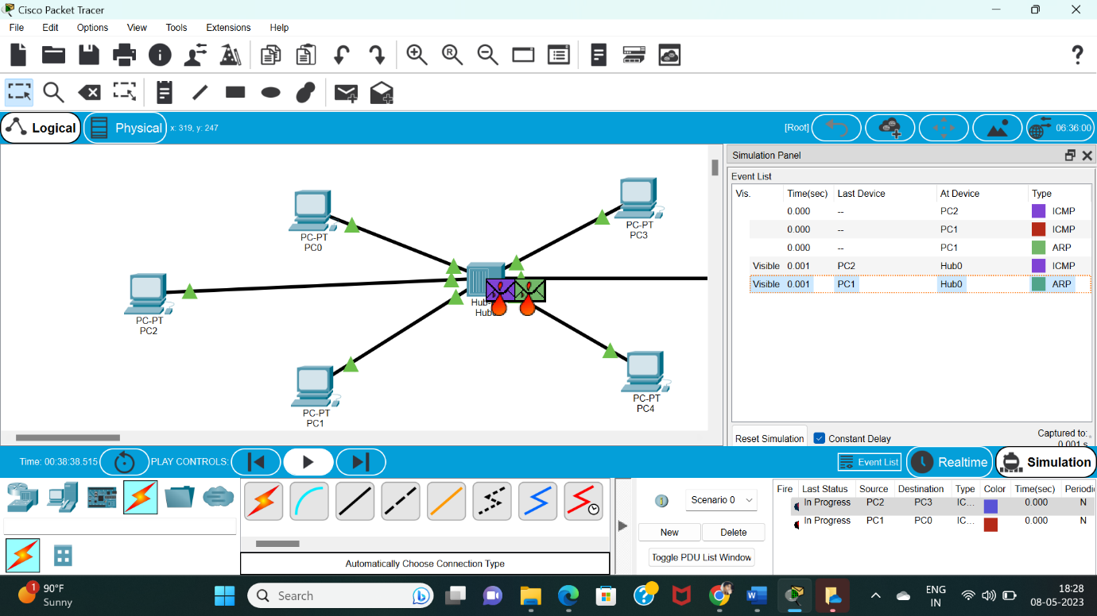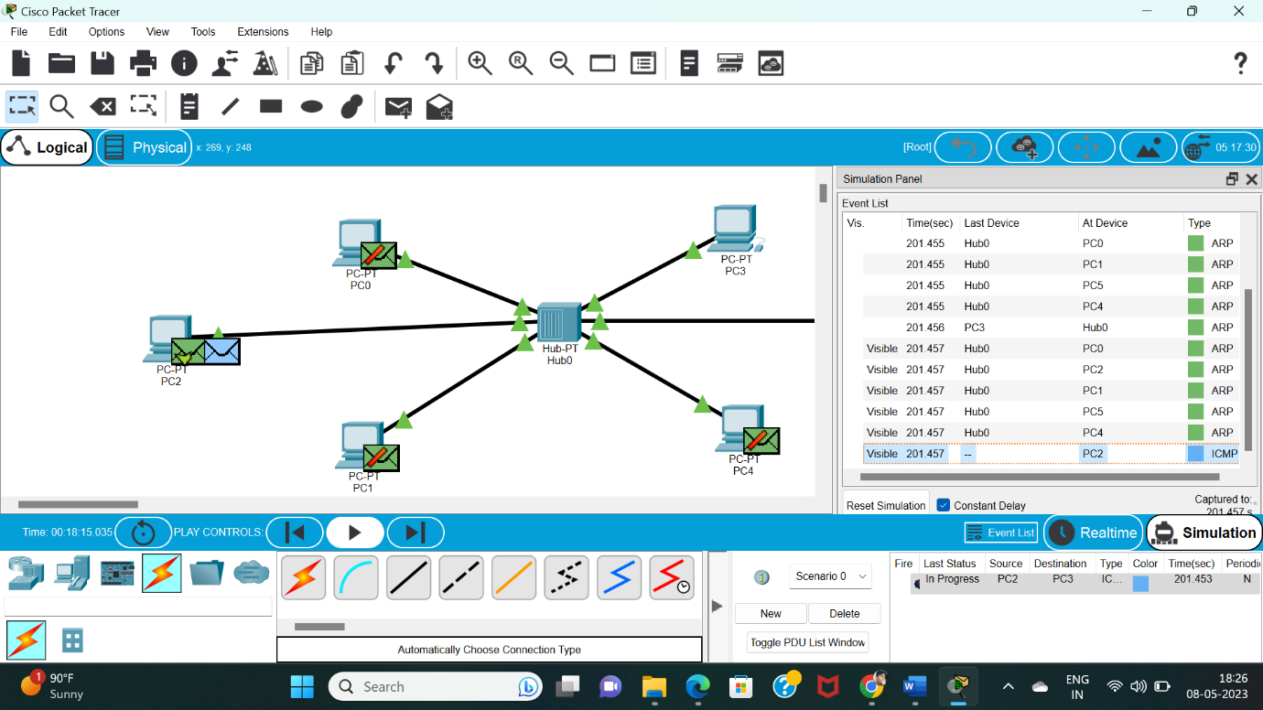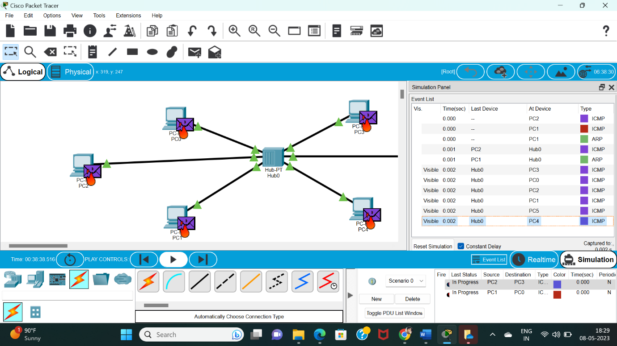

Result:

Configuration of **Data Link Layer Traffic Simulation of ssma/cd** using packet tracer verified successfully.